aim games  
Sprint 2 retrospective

# Summons

|  |  |
| --- | --- |
| Name | Roll |
| De la Fuente Bonilla, Fco. Javier | **CEO, Project manager** |
| Molina Domínguez, Jorge Manuel | **CCO, CIO** |
| Bizcocho González, Mario | **CMO, Product Owner** |
| Arenas Arenas, Antonio  Monteseirín Puig, Alejandro  Pazo Jiménez, Pablo  Pérez Piñero, Iván  Santos Batista, Miguel | **Developers** |

# attendee

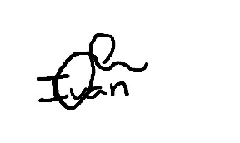**De la Fuente Bonilla, Fco. Javier Pérez Piñero, Iván**

**Arenas Arenas, Antonio Molina Domínguez, Jorge Manuel**

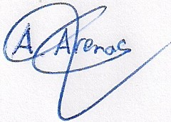

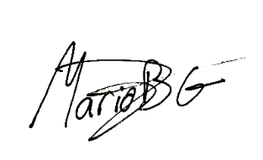**Monteseirín Puig, Alejandro Bizcocho González, Mario**

**Santos Batista, Miguel Pazo Jiménez, Pablo**

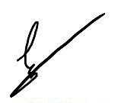

# Absent

No Proceed

# Date and place

Being on Friday April 12, 2019, and verified the attendance of all the summoned, began at 10:00 hrs. To the Sprint 1 retrospective and Sprint 2 planning for the AIM GAMES project, which ended at 13:30 hrs.

# AGENDA

1º Review of things created to date and lessons learned

2º Planning of the 3º sprint

# Development of the meeting and agreements

## Review of things created to date and lessons learned

We have had an easy start of the spring because we had implement the great majority of the uses cases but a little more pressure at the end of it, because of some unexpected conditions of evaluation from the teachers of SEPP, that it result in a more intensive testing and fixing problems , but we could give solutions to every trouble that have been showing up and have finished the sprint satisfactorily.

We had few conflicts because we have had a good implementation of the solutions to the problems of the first sprint, and we had found early a security risk in the system and solved it.

At the end of the meeting we had decide to forgive the warning to Mario Bizcocho and Pablo Pazo since the have worked without any problem in this sprint.

We think that we are prepared to tackle the third sprint without any problems and enhance the MVP with the feedback gained.

## Planning of the 3º sprint

To avoid a big change in any possible plan of the third sprint we will wait until the April 20 to do the Sprint planning meeting, meanwhile we will study the feedback to decided what is useful or not.

# Signed in conformity

